Setting up Application Environment Create Flask Project

|  |  |
| --- | --- |
| Date | 08 November 2022 |
| Team ID | PNT2022TMID34253 |
| Project Name | Skill and Job Recommended |
| Maximum Marks | 2 marks |

**Step 1:** Install Python latest version from python.org

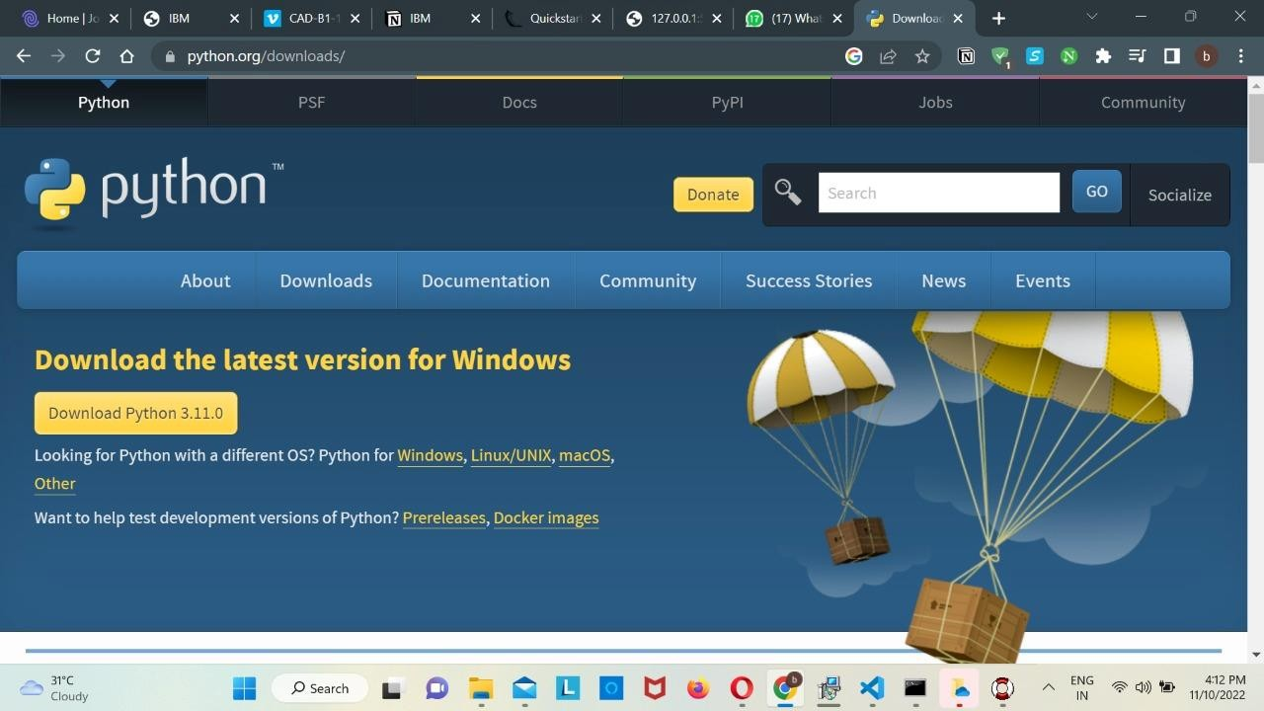

**Step 2:** Download Anaconda from https://[www.anaconda.com/](http://www.anaconda.com/) and install it by running the .exe file



**Step 3:** Install Flask using command pip install flask

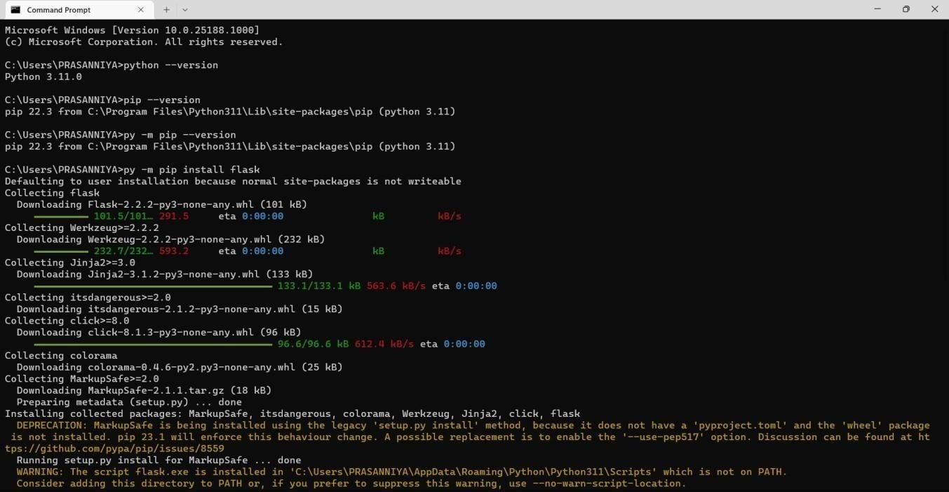

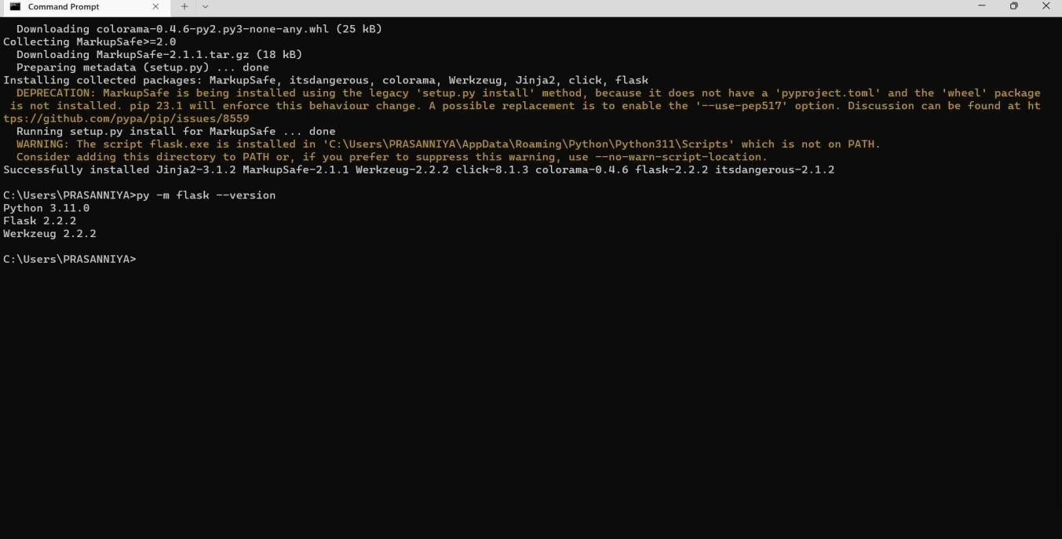

**Step 4:** Open a new Python file and start coding

from flask import Flaskapp = Flask( name ) @app.route('/') def hello():

return “Hello

World”if name ==

' main ':

app.run(debug=True)

**Step 5:** Run the Python file using command python filename.py

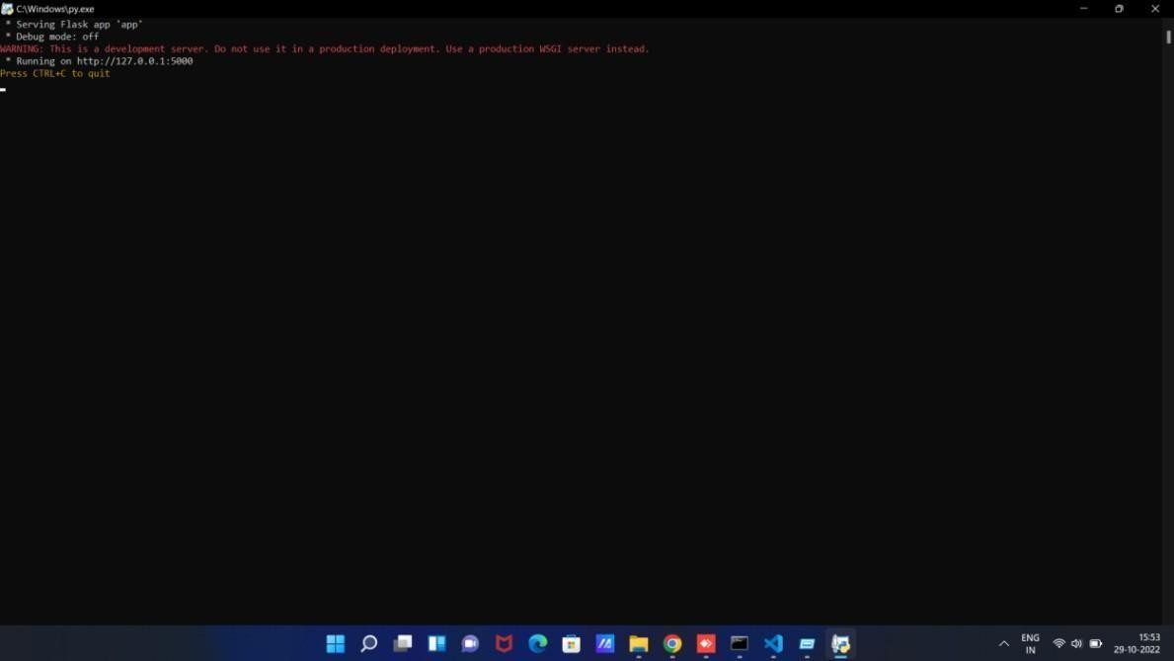

**Step 6:** Open the IP in browser

